The Django Software Environment serves as the primary full-stack web framework and orchestration engine for the ASTRAE platform, connecting front-end interfaces, database ORM models, and back-end machine learning services.

1. Architectural Pattern: Model-View-Template (MVT)
Django’s MVT structure decouples database schema definitions, request-processing logic, and UI rendering:
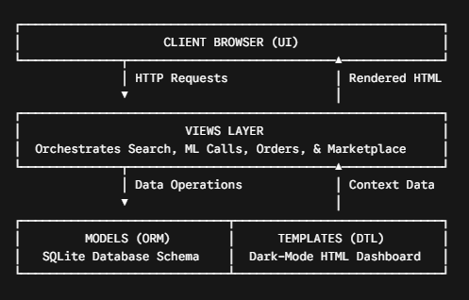
Models (models.py): Utilizes Django ORM to define relational database schemas (Order, Reward, UserCoupon, and native User). Handles data constraints, default fields, foreign key relationships, and automated timestamping.

- Views (views.py): Acts as the controller handling user interactions (usersearch, place_order, sell_coupon, buy_coupon, admin_update_userstatus). Connects HTTP requests to service-layer utilities and returns context-loaded templates.

- Templates (Templates/): Utilizes the Django Template Language (DTL) to render dynamic server-side content ({% for %}, {% if %}, {% url %}, {% csrf_token %}) across user dashboards and admin logs.

2. Modular Application Hierarchy
The Django project is divided into distinct applications to isolate end-user capabilities from administrative oversight:

Application | Core Responsibilities | Key Functions / Features
ASTRAE | Core settings, root routing, static asset management, and WSGI entry points. | settings.py, urls.py, static directory mapping.
ASTRAEUser | Handles user authentication, unified multi-category search, order execution, P2P coupon trading, and rewards ledger. | usersearch, place_order, usercoupons, userrewards, userprofile.
ASTRAEAdmin | System oversight, user account activation, multi-domain order auditing, and Chart.js analytics. | adminhome, admin_update_userstatus, admin_orders_log.
3. Service Layer & AI Engine Integration
Rather than polluting Django views with heavy machine learning computations, ASTRAE separates AI pipelines into a standalone services/ package:

ASTRAEUser/
└── services/
├── chroma_client.py # Local SentenceTransformer + ChromaDB persistent client
├── ride_prediction_service.py # CatBoost ML Inference for Rides
├── food_prediction_service.py # CatBoost ML Inference for Food
├── shopping_prediction_service.py
├── medicine_prediction_service.py
├── recommendation_service.py # Scikit-Learn AIRE RL Ranking Engine
└── order_service.py # Transaction, Points & Coupon Processing
- Singleton Model Caching: Machine learning models (CatBoost regressors, ChromaDB persistent client, and AIRE RL artifacts) are initialized once when Django loads services, preventing re-loading latency during search queries.

- Environment Configuration: Sets TRANSFORMERS_OFFLINE="1" and HF_HUB_OFFLINE="1" via Django settings environment initializers to enforce local model execution from Model/embeddings_model/.

4. Authentication, Security & Database Management
- User Authentication (django.contrib.auth): Leverages Django’s built-in authentication system for user registration, session management (user_login, user_logout), and password hashing (set_password, update_session_auth_hash).

- Access Control Decorators: Enforces security policies using @login_required on user inventory and trading views, and @staff_member_required on administrative control panels.

- Account Activation Workflow: Configures default user registration to is_active=False so admins can approve or toggle user accounts via admin_update_userstatus.

- Database Aggregations: Uses Django ORM query extensions (Sum, Count, annotate, filter, exclude) to calculate real-time analytics for user reward balances, total savings, and Chart.js admin graphs without writing raw SQL.

- CSRF Protection: Protects state-changing HTTP POST endpoints (orders, profile updates, marketplace sales) using Django's built-in {% csrf_token %} middleware.

